ASSIGNMENT 1
Introduction to Amazon Simple Storage Service (S3)

Objectives
After completing this lab, you will know how to:
- Create a bucket in Amazon S3
- Add an object to a bucket
- Manage access permissions on an object and a bucket
- Create a bucket policy
- Use bucket versioning

Step 1: Accessing Amazon S3
Amazon S3 landing page. This is the starting point where the service is introduced as object storage, and you clicked the "Create bucket" button to begin the setup.

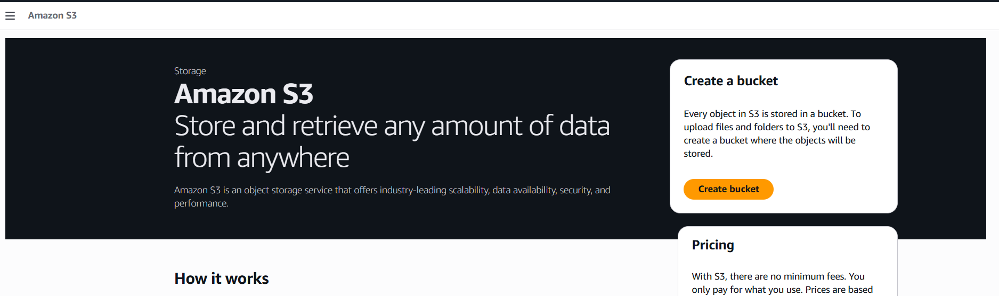

Step 2: General Configuration
you began configuring the bucket:
- Region: Selected Asia Pacific (Mumbai) ap-south-1.
- Bucket Name: Named it "aws-s3-simran".
- Bucket Type: Chose "General purpose" for standard redundancy across multiple zones.
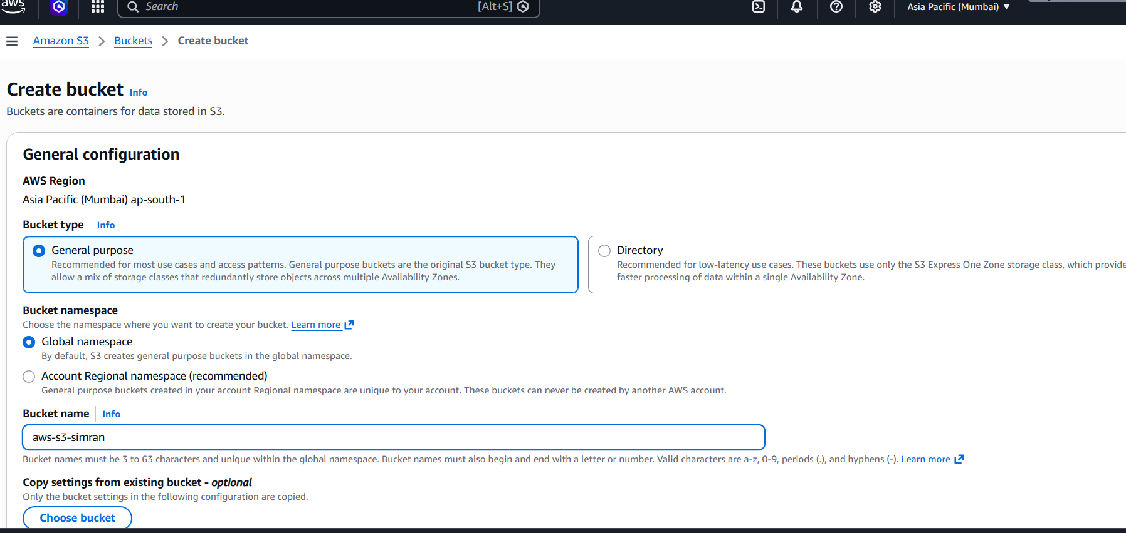

Step 3: Object Ownership
Object Ownership settings. You kept the recommended setting: "ACLs disabled." This ensures that you (the bucket owner) own all objects and manage access primarily through policies.
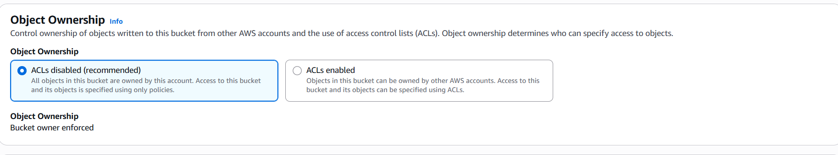

Step 4: Public Access Settings
"Block Public Access" configuration. All boxes are checked to Block all public access, which is a critical security step to keep your data private from the open internet.

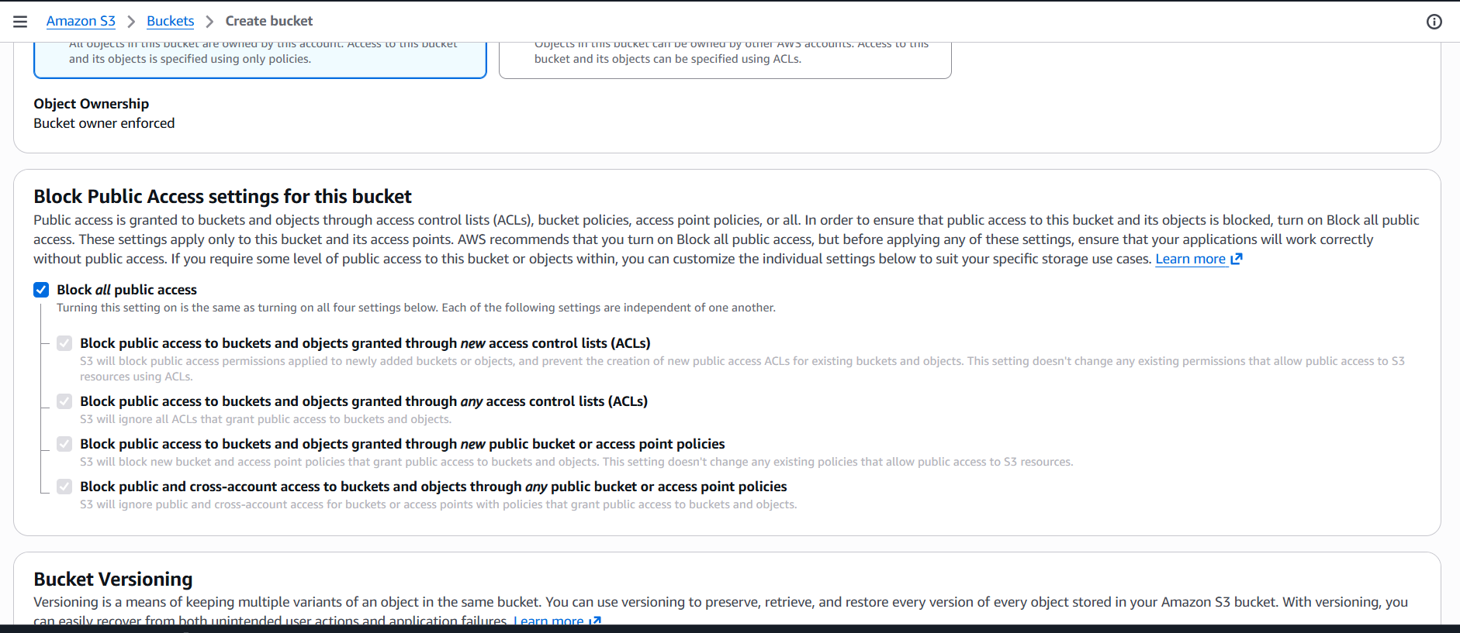

Step 5: Bucket Versioning & Tags
- Bucket Versioning: You kept it Disabled, meaning S3 won't keep multiple historical versions of the same file.
- Tags: No optional tags were added at this stage.

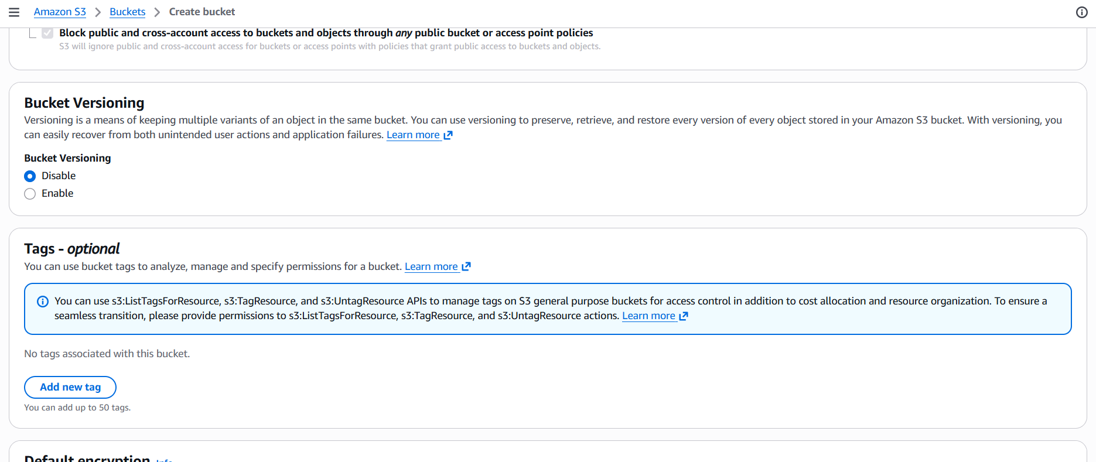

Step 6: Encryption & Finalization
Default encryption settings. You selected SSE-S3 (Amazon S3 managed keys), which automatically encrypts files before they are saved to disk. After this, you clicked "Create bucket."

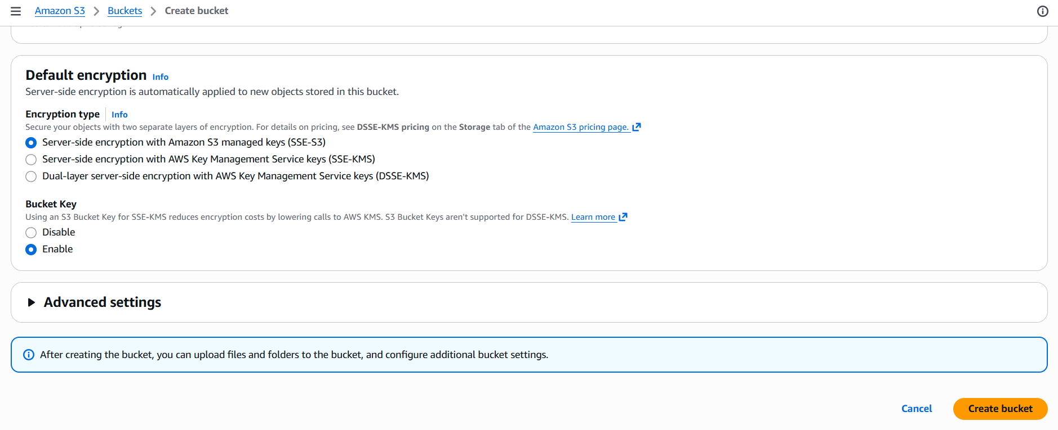

Step 7: Bucket Creation Success
confirms that the bucket "aws-s3-simran" was successfully created. It shows an empty object list, ready for your first upload.

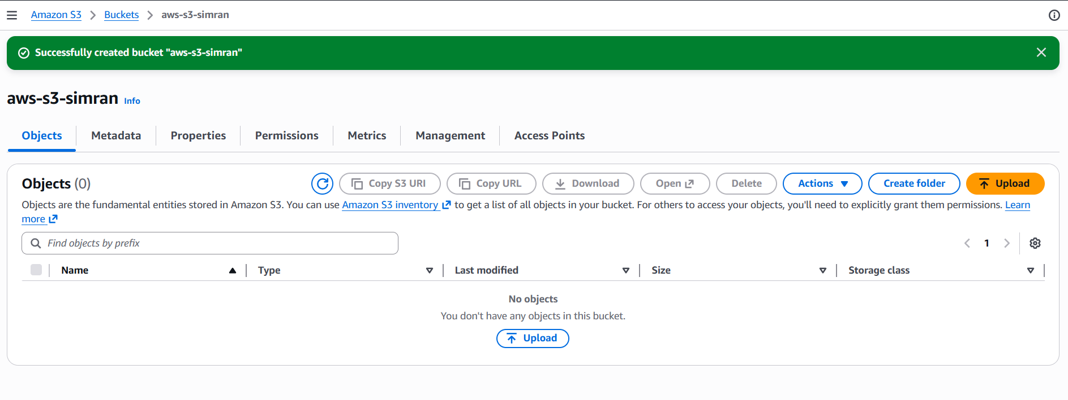

Step 8: Selecting the File
I initiated an upload. You selected a file named "Ultra-realistic cine.png" (1.8 MB) from your local system to be added to the bucket.

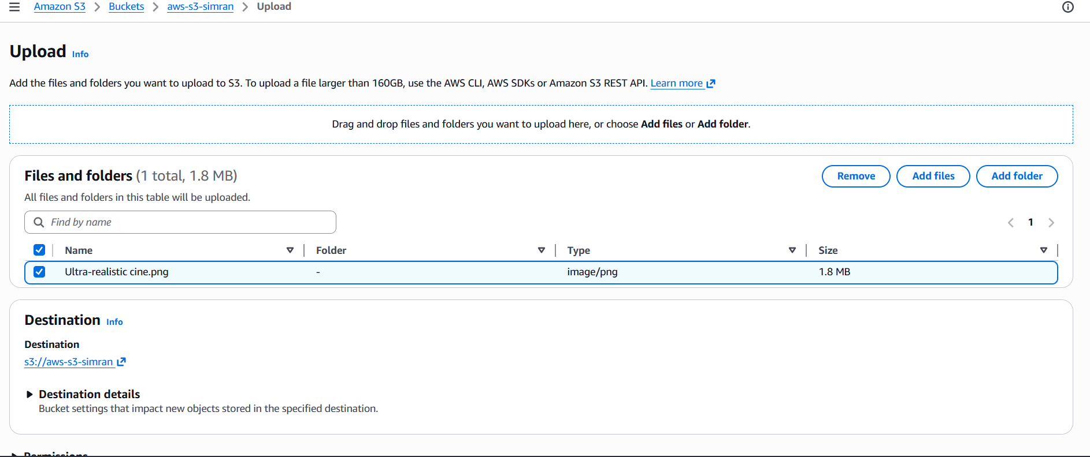

Step 9: Upload Success
shows the Upload status page. It confirms that 1 file succeeded (100% completion) and is now stored in the cloud.

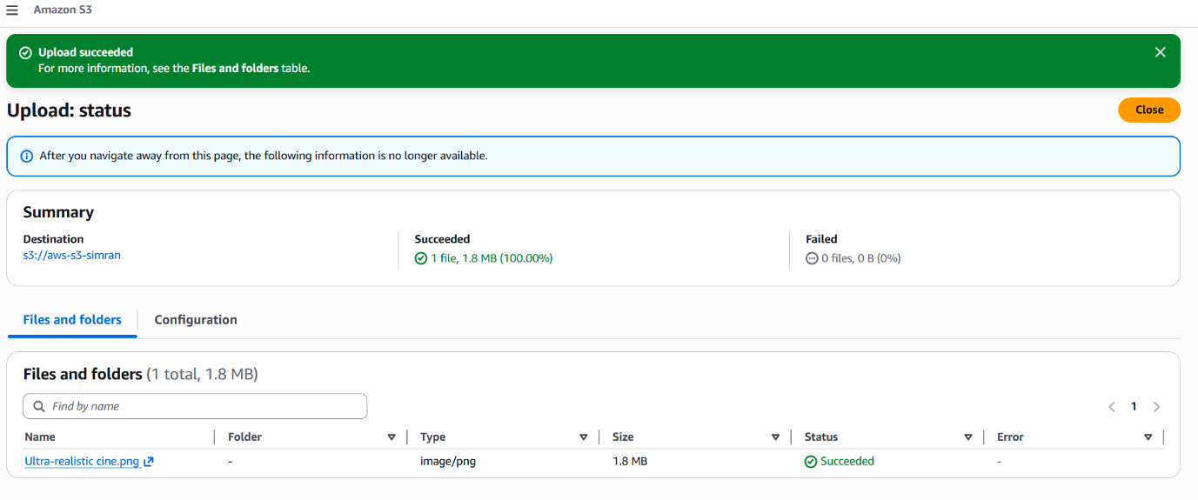

Step 10: Object Properties
Object Overview for the uploaded image. It provides technical details like the S3 URI, Amazon Resource Name (ARN), and the Object URL used to identify or access the file within the AWS infrastructure.

